# **Employee Database**

Note: I have used MySQL server and MySQL workbench (client application)

1. **Create Statement**

CREATE TABLE Employee(

Empno varchar(8) primary key,

EmpName varchar(30) NOT NULL,

department varchar(50) NOT NULL,

email varchar(30) NOT NULL,

phone varchar(11) NOT NULL) ;

1. **Desc Table**

DESC Employee;

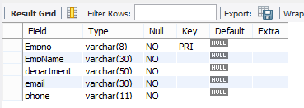

1. **Employee Table rows**

SELECT * FROM Employee;

